

Lab # 07
Mobile Application Development – I Fall 2024



Course Instructor: Mr. Qaiser Khan

Lab Instructor | Mr. Muhammad Ahmed
Student Name | Muhammad Taha
CMSID | 518133
Department | Computer Science
Semester | 4th

Lesson Set 7

Stateful Widgets

Purpose 1. Understand the concept of Stateful Widgets and how they manage dynamic data in a Flutter application.
- Learn how to update UI elements using the setState() method.
- Develop an interactive Flutter application that handles user input and state changes, similar to real industry mobile applications.

Procedure 1. Students should read the Pre-lab Reading assignment before coming to the lab.
- Students should complete the Pre-lab Writing assignment before entering the lab.
- In the lab, students should complete Labs 7.1 through 7.4 in sequence. Your instructor will give further instructions on grading and completing the lab.
- Students should complete the set of lab tasks before the next lab and get them checked by their lab instructor.

Contents | Pre-requisites | Completion Time | Page Number
Pre-lab Reading Assignment | - | 20 min | 3
Pre-lab Writing Assignment | Pre-lab Reading | 10 min | 4
Lab 7
Lab 7.1  Understanding and Implementing Stateful Widgets in Flutter | Pre-lab reading | 30 min | 5
Lab 7.2  Lab Tasks | Develop an interactive Flutter application that handles user input and state changes | - | 9

PRE-LAB READING ASSIGNMENT
What is a Stateful Widget? | In Flutter, widgets describe the user interface (UI) of an application. Some widgets display static content, while others change over time.  A Stateful Widget is a widget whose state can change during the runtime of the application.  Examples of changing state include:  - User pressing a button  - Data being loaded from the internet  - User entering text  - Counters or timers updating  When the state changes, Flutter rebuilds the widget UI automatically.  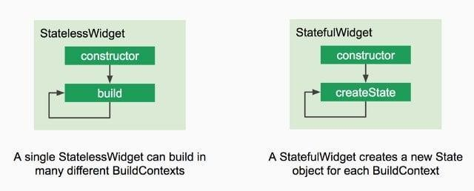

Structure of a Stateful Widget | A Stateful Widget consists of two classes:  - StatefulWidget Class  - State Class  Example structure:  class MyWidget extends StatefulWidget {  @override  _MyWidgetState createState() => _MyWidgetState();  }  class _MyWidgetState extends State<MyWidget> {  }  The StatefulWidget class defines the widget itself.  The State class stores variables that may change and controls how the UI updates.
What is State? | The state represents data that can change during the execution of the application.  Examples:  - Counter value  - User input  - Selected item in a list  - Login status
The setState() Method | The setState() method tells Flutter that the state has changed and the UI needs to be rebuilt.  setState(() {  counter++;  });  When setState() is called:  - The state variable is updated.  - Flutter rebuilds the widget.  - The updated UI appears on the screen.

PRELAB WRITING ASSIGNMENT
Fill in the blanks | - A widget whose state can change during runtime is called a Statefull widget.  - In Flutter, UI updates after state changes are triggered using the setState() method.  - A Stateful widget consists of two classes: StatefulWidget class and State class.  - The function responsible for building the user interface in Flutter is the state class method.  - When a state variable changes inside setState(), Flutter automatically Update and Reload the widget tree.

Lab 7.2 | Lab Tasks

Task 1: Create a Stateful Flutter application that simulates a product quantity management system
Requirements
Students must:
- Create a Stateful Widget for the application screen.
- Display the name of a product (for example: Laptop, Mobile Phone, or Headphones).
- Maintain a quantity counter variable.
- Add two buttons: 1. Increase Quantity, 2. Decrease Quantity
When the user presses:
- Increase → quantity increases by 1
- Decrease → quantity decreases by 1

The quantity must not go below zero.
Display the updated quantity dynamically using setState().

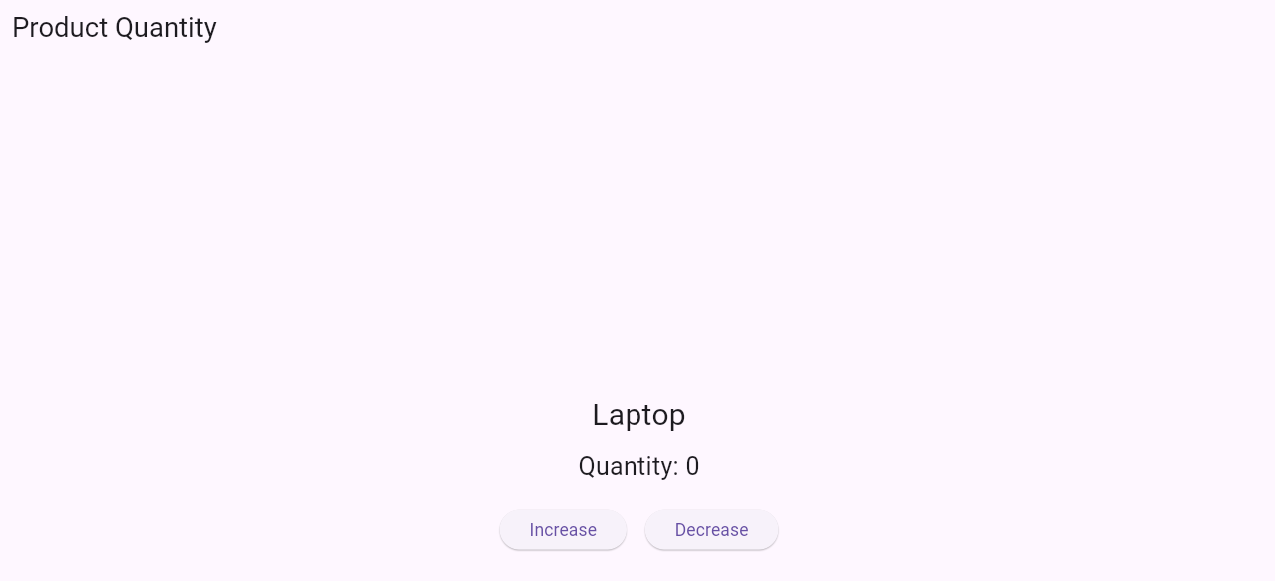
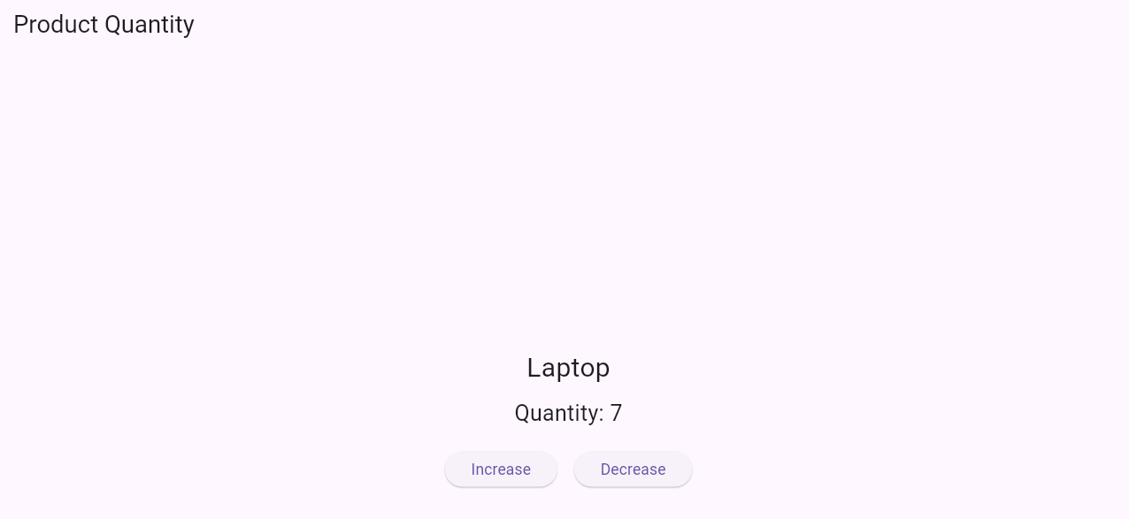
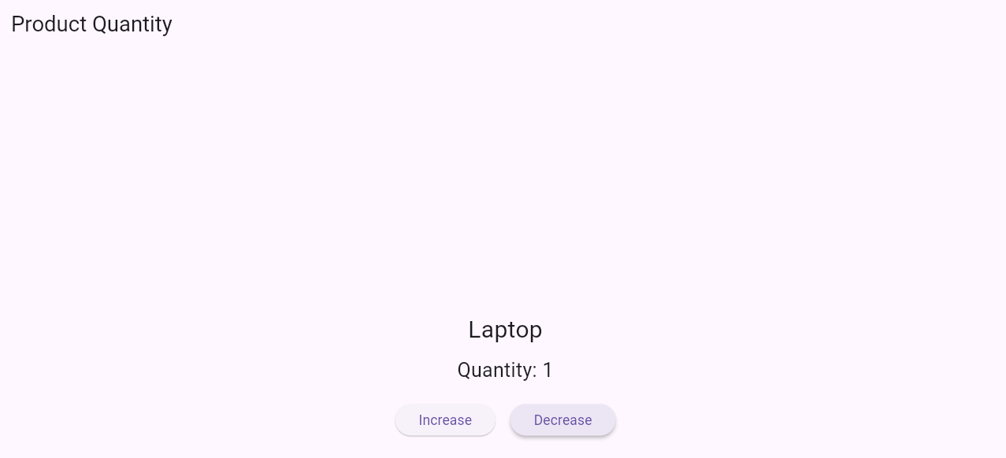

Task 2: Create a Stateful Flutter application that manages multiple products’ quantities simultaneously.

Requirements
- Create a Stateful Widget for the main screen.
- Maintain a list of products (optional or you can also create separate variables for each product), each with:
  - Name
  - Quantity
- For each product, display:
  - Product name
  - Current quantity
  - Two buttons: Increase and Decrease quantity
- Ensure quantity does not go below zero for any product.
- Add a Reset All button to set all quantities back to zero.
- Dynamically update the UI when any quantity changes using setState().

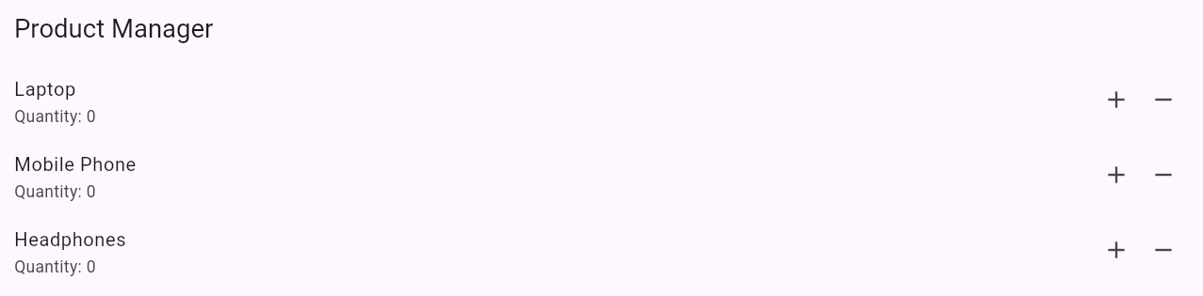
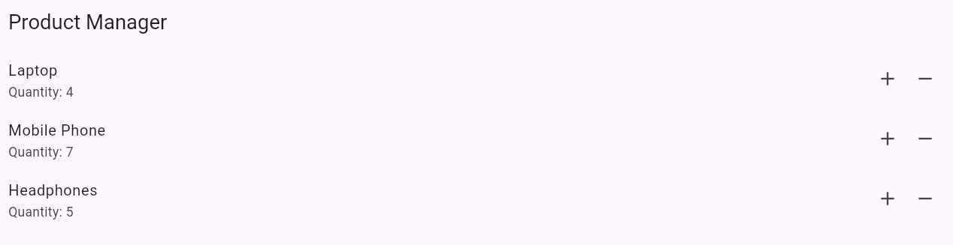
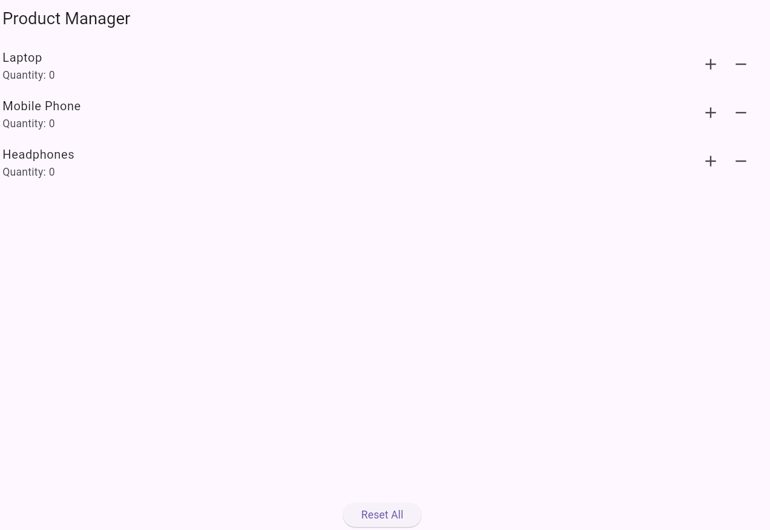
Task 01 Code:
import 'package:flutter/material.dart';

void main() {
runApp(const MyApp());
}
// Root widget of the app
class MyApp extends StatelessWidget {
const MyApp({super.key});
@override
Widget build(BuildContext context) {
return const MaterialApp(
home: ProductPage(),
debugShowCheckedModeBanner: false,
);
}
}
// Stateful screen to manage product quantity
class ProductPage extends StatefulWidget {
const ProductPage({super.key});
@override
State<ProductPage> createState() => _ProductPageState();
}
class _ProductPageState extends State<ProductPage> {
// Product name
final String productName = "Laptop";
// Quantity counter
int quantity = 0
// Increase quantity
void increase() {
setState(() {
quantity++;
});
}
// Decrease quantity (never below 0)
void decrease() {
if (quantity > 0) {
setState(() {
quantity--;
});
}
}
@override
Widget build(BuildContext context) {
return Scaffold(
appBar: AppBar(
title: const Text("Product Quantity"),
),
body: Center(
child: Column(
mainAxisAlignment: MainAxisAlignment.center,
children: [
// Product name
Text(
productName,
style: const TextStyle(fontSize: 24),
),
const SizedBox(height: 10),
// Current quantity
Text(
"Quantity: $quantity",
style: const TextStyle(fontSize: 20),
),
const SizedBox(height: 20),
// Buttons row
Row(
mainAxisAlignment: MainAxisAlignment.center,
children: [
// Increase button
ElevatedButton(
onPressed: increase,
child: const Text("Increase"),
),
const SizedBox(width: 15),
// Decrease button
ElevatedButton(
onPressed: decrease,
child: const Text("Decrease"),
),
],
)
],
),
),
);
}
}

Task 02 Code:
import 'package:flutter/material.dart';
void main() {
runApp(const MyApp());
}
// Root of the application
class MyApp extends StatelessWidget {
const MyApp({super.key});
@override
Widget build(BuildContext context) {
return const MaterialApp(
home: ProductListPage(),
debugShowCheckedModeBanner: false,
);
}
}
// Stateful page to manage multiple products
class ProductListPage extends StatefulWidget {
const ProductListPage({super.key});
@override
State<ProductListPage> createState() => _ProductListPageState();
}
class _ProductListPageState extends State<ProductListPage> {
// List of products with quantities
List<Map<String, dynamic>> products = [
{"name": "Laptop", "qty": 0},
{"name": "Mobile Phone", "qty": 0},
{"name": "Headphones", "qty": 0},
];
// Increase quantity of a product
void increase(int index) {
setState(() {
products[index]["qty"]++;
});
}
// Decrease quantity (never below zero)
void decrease(int index) {
if (products[index]["qty"] > 0) {
setState(() {
products[index]["qty"]--;
});
}
}
// Reset all quantities to zero
void resetAll() {
setState(() {
for (var product in products) {
product["qty"] = 0;
}
});
}
@override
Widget build(BuildContext context) {
return Scaffold(
appBar: AppBar(
title: const Text("Product Manager"),
),
body: Column(
children: [
// List of products
Expanded(
child: ListView.builder(
itemCount: products.length,
itemBuilder: (context, index) {
var product = products[index];
return ListTile(
title: Text(product["name"]),
subtitle: Text("Quantity: ${product["qty"]}"),
// Increase / Decrease buttons
trailing: Row(
mainAxisSize: MainAxisSize.min,
children: [
IconButton(
icon: const Icon(Icons.add),
onPressed: () => increase(index),
),
IconButton(
icon: const Icon(Icons.remove),
onPressed: () => decrease(index),
),
],
),
);
},
),
),
// Reset button
Padding(
padding: const EdgeInsets.all(12),
child: ElevatedButton(
onPressed: resetAll,
child: const Text("Reset All"),
),
)
],
),
);
}
}

